**Mini Project**

**Address Book Management**

**Using**

**C Programming**

**by**

**Ragul Krishna**

**ID-105599**

Table of Contents:

|  |  |  |
| --- | --- | --- |
| Sl no | Name | Page No |
| 1 | Problem statement | 1 |
| 2 | Description | 1 |
| 3 | Data requirements | 2 |
| 4 | Test plan | 2 |
| 5 | Expected output | 3 |

Problem statement:

 An enormous problem is that people encounter a lot of addresses each day. Whether it is their friend’s address or be the location of offices in new cities and so on. It is difficult to keep track of the addresses.

Description:

Address book system is used to store the information that can be difficult to keep track. The basic concepts of C like Functions, pointers, files handling are used in this program.

Address book management system is based on the concept to store personal or an organization addresses and view it. Adding new records, listing them, deleting them, and converting it into a HTML file to view in a browser. These are the basic functions which make up the main menu of the address book management system. The system is especially useful to get the address. Personal information such as name, phone number, address, email, and current location are asked while adding a record into the address book. These records can then be added, viewed, converted into a html file, and deleted.

For main menu switch case is used and displayed all the options of menu

Menu list includes:

* Add new addresses means adding new address with specified fields
* View all addresses means to list the details of every record stored.
* Convert means converting the existing file into a HTML document which can further be viewed in the browser.
* Delete all addresses means deleting all the fields stored.

 Objective:

The primary of address book management systems is that the addresses can be stored in a software thus reducing the effort to remember each address. Information is stored in a single go. Mistakes can be reduced. Slight mistakes in the address may result in documents getting lost or stuck up while in transit.

Data Requirements

The user must be aware of the addresses that is being entered. Whether any false data entered cannot be checked unless the user finds it. The data stored can be shared.

System Requirements:

Hardware Requirements:

Ram:1GB or above

Rom: >20MB

Software Requirements:

OS: Windows

IDE: Code:: blocks or Dev C++

Compiler: Mingw

System design:

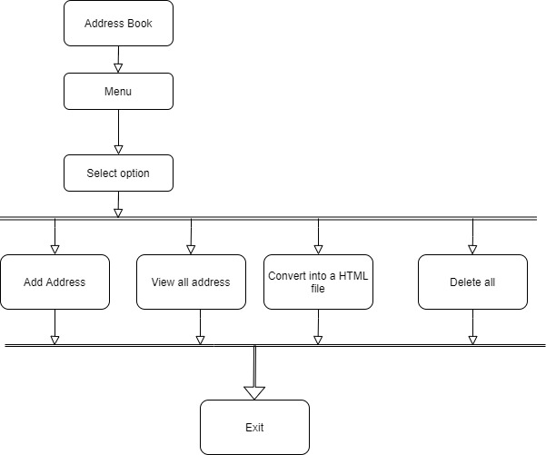

4.TEST PLAN:

|  |  |
| --- | --- |
| SI No. | Test Objective |
| 1 | To check if the program menu displays all the options without errors |
| 2 | To check if the user can do the entry |
| 3 | To check if the system displays all the addresses |
| 4 | To check if the user can delete all the addresses in the book |
| 5 | To check if the address stored is converted into a HTML file |

Test Cases:

|  |  |  |  |
| --- | --- | --- | --- |
| S.NO | OBJECTIVE | EXPECTED RESULT | ACTUAL RESULT |
| 1 | To check if user can add a new address | User can add an address with attributes such as name, address, Phone number, email, City, Postal code | Successfully added new address into the address list |
| 2 | To check if the user can view the existing addresses | View all the existing addresses with their respective attributes | Successfully shows all the addresses in the address list |
| 3 | To check if user can exit from the current screen | Exit from the current screen | Successfully exited from the current screen |
| 4 | To check if user can convert the address stored into a HTML file | User can convert the addresses into HTML file | Successfully converted the addresses with attributes into HTML file |
| 5 | To check if user can delete all the addresses | User can delete all addresses with attributes from the address book | Successfully deleted all the addresses with attributes from the address book |

Expected output:

The address book is a mini project that helps us to store our address with the required details. It replaces manual waying of storing details. This will help users to easily store and manage addresses using this system. Address book is one which contains details of an individual address with other details such as name, email, phone number, city, postal code. The address stored is also converted into a HTML file. The aim of the mini project was to build an address book management which allowed to add, view, convert, delete the records.